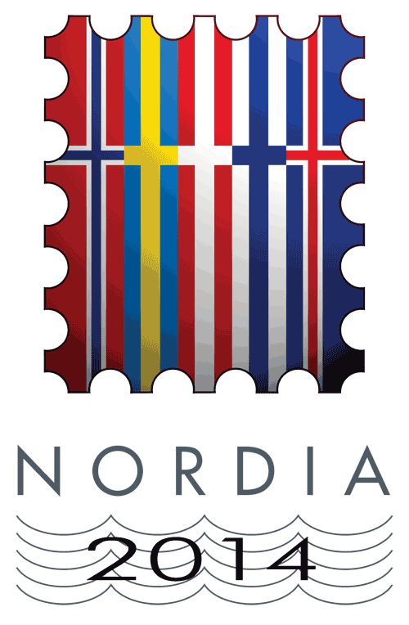 | NORDIA 2014  Lillestrøm 21-23.11.2014 | Eksponat nr. | Ramme nr.
 | Exhibition application form | For use of the exhibition committee

Exhibitor information
Surname | First name | Date of birth  (for youth exhibitors)
Pseudonym if applicable

Address

Postal code | City | Country
Phone number | E-mail address

Exhibit information
Title

Short description

Introduction page included: YES
Class | No. of frames applied for | Sheet size (w x h) cm

Delivery, mounting and dismounting of the exhibit
Exhibitor or his/her representative will deliver the exhibit |  | The exhibit will be delivered by mail
Exhibitor or his/her representative will mount the exhibit |  | Exhibition committee will mount the exhibit
Exhibitor or his/her representative will dismount the exhibit |  | Exhibition committee will dismount the exhibit

Past awards received by the exhibit
International (FIP/FEPA/NORDIA) exhibitions | LG | G | LV | V | LS | S
National exhibitions |  | G | LV | V | LS | S

I hereby accept all the FIP regulations and the Nordia 2014 special regulations
Place | Date
Signature of the exhibitor
(youth exhibitors also need approval from parents)
Signature of commissioner

Send the application form to your local commissioner
Don’t forget the plan and synopsis if applicable

